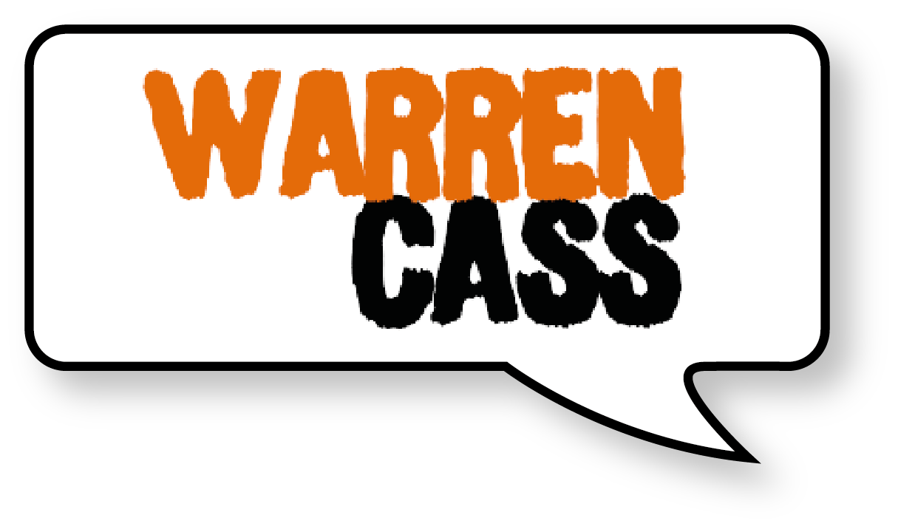 | Pre-Event Speaking Questionnaire

CONTACT INFORMATION

Completing this form will help Warren to contextualise his talk for your audience & ensure it has maximum impact.
Not all questions will be relevant but the more information the better.

Name :
Phone :
Title :
Company Name :
Website :
Best Time For Warren To Reach You :

YOUR EVENT

What is your event theme?
What is the purpose of this event?
What type of event is it? (AGM, awards ceremony, sales kick-off etc)
Who (if anyone) is on the program just before Warren and what is their presentation topic?
Who (if anyone) is on the program right after Warren and what is their presentation topic?
Which company executives and/or industry experts will be speaking at this meeting?

THE PRESENTATION

What is Warren's role in your program (opening or closing, keynote, breakout, etc.)?

What are the exact times for Warren's presentation?

Start Time:
End Time:

* Please send us a copy of the meeting program and agenda so he can see how his program fits in. Thank You!

Who will be introducing Warren to your group?

What is most important to you concerning the content of Warren's presentation? (i.e. use of examples, exercises, handout, etc.)

What is most important to you in the working relationship with Warren?

What themes/threads (other than the primary topic of Warren's presentation) would you like to see woven into the presentation?

THE AUDIENCE

Number in the audience:
How will most of the audience be dressed?
Male/Female Percentage: M F
Average age of attendees?
How would you define your audience? Staff/Members/Industry/Public/Business Owners?
When your people leave the presentation, what three concepts/skills/ideas would you like them to have?

1.
2.
3.
How would you like your audience to feel after the event?

AUDIENCE BACKGROUND

What separates your high-achievers from the others?

What are some of the challenges your organization and your people/members face on a day to day basis?

What areas of challenge pose the greatest opportunity for improvement?

What are the most significant events that have occurred, and that have affected, your industry, organisation, or group during the past year? (i.e. mergers, downsizing, etc.)

What is the primary product or service that you offer?

What are the two most important benefits you offer to your customers?
A.
B.
What are two or three achievements of which your organisation is most proud?

Name five key people in your group that will be at the programme. With your permission, Warren may want to contact them to discover more information about your group.
Name / Telephone #

1.
2.
3.
4.
5.

LOGISTICAL INFORMATION

Hotel Name & Address:

Phone:
Hotel Confirmation Number:
Name of meeting room:
Into what airport should we schedule Warren's flight?
How far is the hotel from the airport?
How should Warren travel to the hotel? (take cab, rent car, driver will pick up, etc.)?
Would you like Warren to notify someone after he arrives at the hotel?
If so, whom shall he contact:
Phone:
Contact at meeting site:
Name:
Title:
Phone:
On site arrival date:
Are there any pre-meeting engagements (i.e.breakfast or lunch)?
If so, where and when are they scheduled:
------------------------------------------------------
Misc notes:

